­ 

**<Project Name>**

**Business Requirements Document**



**Project #:**

**Client/Mandate code:**

**Version: X.X**

**Prepared by:**

**Contributors:**

**Date:**

Our **client service principles** are the framework   
we use to deliver **client service excellence**.

**We will:**

** make** and meet our commitments to you

** understand** your business and what is important to you

** provide** value and build trust through technical competence and consistent results

** demonstrate** professionalism through effective interaction and communications

 provide a **no surprises** experience

We invite you to assess our performance against these principles through our Client Feedback process.

**Guidance:**

***<SDLC Phase: DEFINE>***

|  |  |
| --- | --- |
|  | Business Requirements Document Doc (BRD) |
| **Project Lead** | C |
| **BA** | **R** |
| **Data Analyst** | C |
| **Development** | I |
| **QA** | I |
| **Usability** | I |
| **Business Owner** | **A** |
| **Portfolio Management** | I |
| **Product Owner** | C |
| **Business Team** | C |

**R –** Responsible **A –** Accountable  **C –** Consulted **I** **-** Informed

*<The purpose of this document is to capture the requirements of interest to the business and stakeholder(s). It serves as the agreement between the project team and Business Owner about the product to be built or business process improvement. The BRD is the basis for all subsequent project planning, functional requirements, as well as the foundation for system testing and user documentation. It is a key component of your overall Requirements Package.>*

*<Document Conventions>*

*<*

*1. When using this template you are provided the latitude to enhance certain sections based on the needs of the Client in an effort to clearly communicate their requirements. Not all projects will use each section of this template. It is a guideline for best practices to assist with capturing requirements that are clear, concise, consistent and correct. The advantage of a template is to get you to think about what you are working on, and to remind you of questions you can ask while you elicit the information.*

*2. Sections that are not completed should remain in the template and labeled as N/A. This will help to create a consistent standard being used. Section headings can be modified to assist with communication using terms that are familiar to the Client.>*

*3. All comments contained within the chevrons (<>) must be removed prior to sharing this document for review>*

*4. The table of contents must be updated each time the document is saved to reflect proper page numbering*

*>*

**Document Control**

**Document Information**

|  |  |
| --- | --- |
| **Document Name** | Business Requirements Document |
| **Project Name** | *<Insert project name>* |
| **Document Author(s)** | *<Insert author(s) name(s)>* |
| **Document Status**  **(First Draft, First Final, Final Revisions)** | *<Insert document status>* |
| **File Name** | *<Insert path and file name>* |

**Document History**

*<This table captures the history of this document. Add a new line each time the document is revised*

*for version numbering follow these guidelines:*

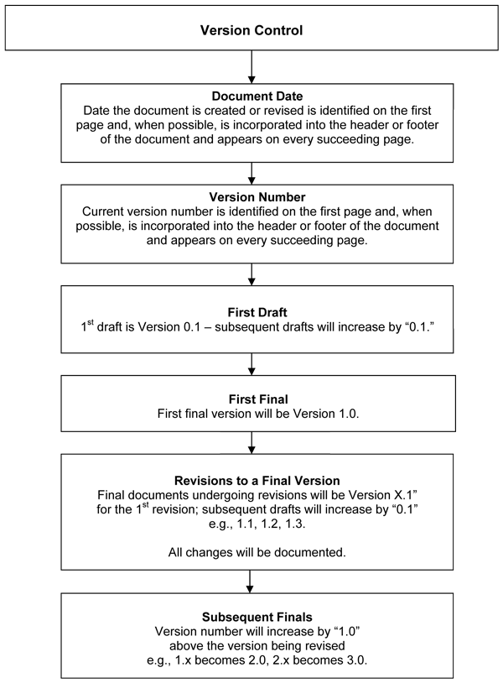

*The first final is the version that is sent to the client for final approvals.>*

| **Version** | **Date** | **Additions/Modifications** | **Prepared/Revised by** |
| --- | --- | --- | --- |
| *<Version #>* | *< dd-mmm-yyyy >* | *<Provide details about the changes in the document>* | *<Name>* |
|  |  |  |  |
|  |  |  |  |
|  |  |  |  |

**Document Review**

*<This table captures the review history of this document. To determine the individuals who fill those roles for this project, consult the Project Charter or the Project Manager. At the Project Manager’s discretion, additional individuals may be asked to review or approve the document.>*

| **Date** | **Version** | **Name** | **Title** | **Comments** |
| --- | --- | --- | --- | --- |
| < dd-mmm-yyyy > | <Version #> | <Name> | <Title> | <Comments> |
|  |  |  |  |  |
|  |  |  |  |  |
|  |  |  |  |  |
|  |  |  |  |  |

**Table of Contents**

**1.** **Document References** 8

**2.** **Glossary** 9

**3.** **Introduction** 10

**3.1** **Purpose of Document** 10

**3.2** **Target Audience** 11

**4.** **Project Summary** 12

**4.1** **Project Background** 12

**4.2** **Project Vision** 12

**4.3** **Problem Statement** 12

**4.4** **Benefits** 13

**4.5** **Business Case / Goals** 13

**4.6** **Project Scope** 13

**4.6.1** **In Scope** 13

**4.6.2** **Out of Scope / Future** 13

**4.7** **Assumptions** 13

**4.8** **Constraints** 14

**4.9** **Dependencies** 14

**4.10** **Risks** 14

**4.10.1** **Risks to Completion** 14

**4.10.2** **Risks to Inaction** 14

**5.** **Business Process** 15

**5.1** **Current State (As-Is)** 15

**5.2** **Future State (To-Be)** 16

**6.** **Data Flow/System Context/Activity Diagrams** 17

**7.** **Requirements** 19

**7.1** **High Level Business Requirements** 19

**7.2** **Functional / Non-Functional Requirements** 21

**7.2.1** **B 1.1 <Brief Heading>** 22

**8.** **Appendix** 23

**9.** **Acceptance – Signoff** 24

# **Document References**

*<This section list all links/references to additional project documents (as required).These can include the project charter, project plan, resource plan, requirements work plan, IT Service Request.>*

*<Links should be to a team site or other shared location that is accessible by all stakeholders and project team members. Avoid imbedding documents as objects since changes could be made to the document. The current version of the document should always be linked to. >*

| **Document** | **Link** |
| --- | --- |
| Project Charter | < Link > |
| <Document> | < Link > |
| <Document> | < Link > |
| <Document> | < Link > |

# **Glossary**

*<This section provides the definitions of all terms, acronyms, abbreviations, symbols, and notations required to properly interpret the Requirements Document.>*

| **Term** | **Description** |
| --- | --- |
|  |  |
|  |  |
|  |  |

| **Acronyms** | **Description** |
| --- | --- |
|  |  |
|  |  |
|  |  |

| **Abbreviation** | **Description** |
| --- | --- |
|  |  |
|  |  |
|  |  |

| **Symbol** | **Description** |
| --- | --- |
|  |  |
|  |  |
|  |  |

*<add additional rows as necessary>*

# **Introduction**

## **Purpose of Document**

*<This section defines the purpose of the Business Requirements Document in the overall project documentation identifying it as a key component of the requirements package. It will capture the high level requirements, functional requirements and non-functional requirements.*

* ***High Level requirements******-*** *specify the goals and objectives the business wishes to achieve through the implementation of a system/enhancement.*
* ***Functional requirements –*** *the product capabilities, or things that the product must do for its users.*
* ***Non-functional requirements*** *– the quality attributes, design and implementation constraints, and external interfaces that the product must have.*

*<Please note that the Business Requirements Document does not contain Use Cases or User Stories. These should be provided as a separate document once the BRD has been approved.>*

*A sample of the text for this section is shown below:*

The purpose of this document is describe in detail the high level, functional and non-functional requirements of “Project Name” and provide an overview for “Project Name” implementation.

Its main purpose is to –

* Describe the business objectives for the project
* Detail the functionality and capabilities that the system is to adhere to
* Define the quality attributes and the constraints of the system
* Act as the basis for the development and test phases

*>*

## **Target Audience**

*<The specific audience for the document needs to be identified along with an indication of how they are expected to use the document. The section lists the intended audience of this document in the below table format.>*

| **Name** | **Title** | **Project Role** |
| --- | --- | --- |
| <Name> | <Title> | <Project Role> |
|  |  |  |
|  |  |  |

*< Add additional rows as necessary>*

# **Project Summary**

*<A significant portion of the content for this section will be provided by the project charter and business case. The details in this section will align directly with the project documents produced through the PMLC>*

***<***This entire section can be replaced with a link to the initial project documentation created during the project planning phase (ie. Project Charter) only if each sub section has already been properly documented and approved. IF no document exists that provides the necessary details you must complete this section in its entirety.***>***

## **Project Background**

*<This section describes the project background, including the need for executing the project. This explains high-level information about the initiative and the business problem(s) to be addressed. >*

## **Project Vision**

*<This section identifies how this project is aligned with the business strategy that the project is intended to support.>*

## **Problem Statement**

*<This section may be OPTIONAL depending on the type of project. It can be replaced with a section titled “Business Need” or “Objectives”.>*

*<This section identifies the problem statement and provides a concise description of the problem to be resolved.*

*It covers five components listed below:*

* *Magnitude of the problem*
* *How long the problem has been occurring*
* *A description of the problem*
* *Specifically where the problem is occurring*
* *The metric used to measure the magnitude and severity of the problem>*

## **Benefits**

*<This section includes the benefits which may affect the project. Benefits are the intended effects of a project. They explain the reasons for solving the problem statement.>*

*<*A sample of the section is shown below:

* The implementation of automated scripts reduces manual password reset processes to 10% of the original time.*>*

## **Business Case / Goals**

*<This section helps ensure that all business requirements are tied to business goals. Business case is made by understanding the cost-saving or revenue-generating opportunities of the project.>*

## **Project Scope**

*<This section describes the scope of the document and what is affected or influenced by this document. This section should be populated from the Project Charter.>*

### **In Scope**

*<This section includes all the requirements in scope of this project/phase. Can be presented as a bulleted list.>*

### **Out of Scope / Future**

*<This section includes all the requirements not in scope of this project/phase. Can be presented as a bulleted list.>*

## **Assumptions**

*<This section identifies statements that are presumed to be true in the absence of proof and definitive knowledge. The following are the assumptions that were made when defining the application’s requirements and when preparing this document. Reference data from Project Charter for Assumptions.>*

## **Constraints**

*<This section defines the limitations to the proposed system/enhancement. Reference data from Project Charter for Constraints.>*

## **Dependencies**

*<This section identifies the system requirements that have a reliance on external forces outside of its control. External forces include, but are not limited to: events, groups, projects, stakeholders. Reference data from the Project Charter for Dependencies.>*

## **Risks**

<This section describes risk as any concern that might adversely affect the project; specifically, a potential inability to meet a given requirement. Reference data from Project Charter for Risks.

Risks should be identified such that:

* Additional requirements may be added or removed in order to mitigate the risks
* The project manager is made aware of any remaining risks that should be addressed>

### **Risks to Completion**

<This section lists risks that may be incurred by implementing these requirements.>

### **Risks to Inaction**

<This section lists risks that may be incurred by not implementing the project/requirements.>

# **Business Process**

***<Recommended>***

*<This section consists of high level graphical models of business process operations. The models should be understandable by all users, from the business users and business analysts that create the initial drafts of the processes, to the technical developers responsible for implementation. Where possible, the standard modeling technique to be used is BPMN.*

*The level of decomposition applied to the analysis depends on the purpose and scope of the project. Not all projects require analysis to the lower process levels. Projects concerned with information systems development may have more detail than business improvement projects.*

*Listed below are some guidelines to developing the levels of process flow diagrams.*

* *Shows major processes that are a part of the overall system (sub processes can also be identified)*
* *Shows how the major processes are interrelated by data flows*
* *Shows external entities*
* *Identifies key participants, departments or products as swimlanes*
* *Models should be created using MS Visio or Deloitte’s IndustryPrint Process Modeller (*[*https://industryprint.deloitteresources.com*](https://industryprint.deloitteresources.com)*) >*

## **Current State (As-Is)**

<This section depicts the current business process model of the existing system workflow and/or operation. >

A sample of the section is shown below:



## **Future State (To-Be)**

<This section describes the desired business process model of the intended system/operation upon completion of the project. By refining the future model, requirements are generated for each component. These requirements need to be captured and documented in later sections of this document.>

A sample of the section is shown below:



# **Data Flow/System Context/Activity Diagrams**

***<If applicable>***

*<A picture, that defines a solution, context or activity flow that is up for discussion. These diagrams usually document the inputs/outputs of the system at a high level. They are used to assist with defining the scope of the project and its boundries.>*

*<Edit the section title to include just the name of the diagram(s) included (eg. 6 System Context Diagram)*

*Examples:*

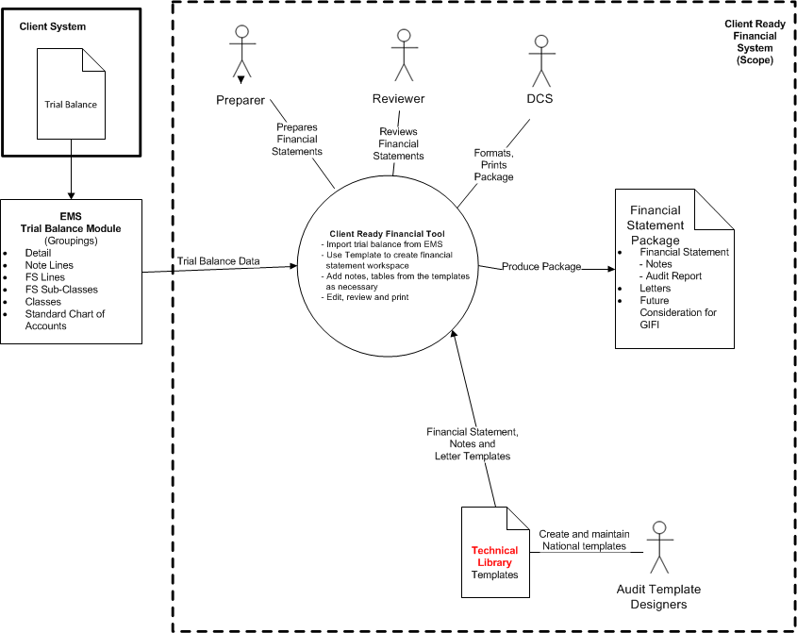

Context Diagram 1

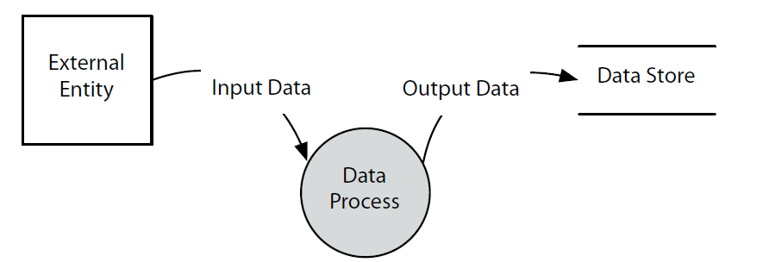

Data Flow Diagram 1

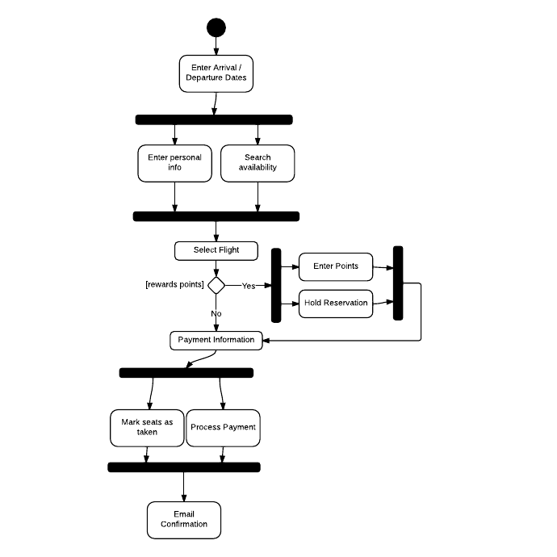

Activity Diagram 1

***>***

# **Requirements**

## **High Level Business Requirements**

<*Business requirements**specify the goals and objectives the business wishes to achieve through the implementation of a system/enhancement.>*

*<This section describes the high level business requirements of what the system must do. They are listed as major features that are needed to satisfy the stated goals of the project. They are the general answer to the problem statement.>*

*<For each business requirement, provide a clear and concise description of the business requirement. Business requirements are written from the business perspective. They are simple descriptions written in business language (i.e. Provide the ability to generate reports. Provide the ability to capture customer information).* ***They are in the format: “Provide the ability [to do an action] so that [a benefit is delivered].****”>*

*<High Level requirements can be presented with the following table structure. You may add additional columns if required to further clarify a requirement. All business requirements will have “B” as the prefix.>*

| **ID** | **Type** | **Description** | **Requirement** | **Priority** |
| --- | --- | --- | --- | --- |
| B 1.1 | Application  Submit | External user | Once on the Fast50 Application site, users should be able to enter and submit an application. |  |
| B 1.2 |  |  |  |  |
| B 2.0 |  |  |  |  |

*<Setting the Priority for requirements can be determined using 2 different methods:*

1. ***Prioritization by implementation order****. Prioritizing requirements is the requirements task of determining the implementation order of the requirements in an incremental and iterative development cycle. (essential for Agile projects).*

*Notation methods: typically uses a numerical scale based on the number of development sprints.*

1. ***Prioritization by importance.*** *Prioritizing requirements is determining the order of importance to some stakeholder or class of stakeholders of the requirements along one or more dimensions (e.g., personal preference, business value, cost of implementation, and risk).*

*Notation methods: MoSCoW, agreed to numerical scale with stakeholder >*

## **Functional / Non-Functional Requirements**

*< Use this section to capture all of your detailed functional and non-functional requirements. You can any of the below mentioned options to document functional and non functional requirements>*

*<* ***Option1:*** *Use this embdedded worksheet to capture all of your detailed functional and non-functional requirements. Guidance on the use of the template is provided in the first tab of the workbook. The columns in the template are guide and show best practices for documenting requirements. The format can be changed based if further detail or attributes need to be captured for your requirements.*

***Instructions:***

*- Open the requirements template using the icon below*

*- Save the template with a new name (ie. Name of project)*

*- Insert your rows of requirements into the saved version*

*- Attach the custom version to the document*

*- Insert as an “Obect” from the “Insert” ribbon/toolbar*

*- Open the “Create from file” tab and browse to the location of your saved version*

*- Check the display as icon box*

*- Select “change icon” and use the Excel icon, update the caption if necessary*

**

***Option 2:*** *Instead of using embedded excel, you can also use one of the below formats to capture functional requirements in tablular form. In this case, you have to create separate section 7.3 Non-Functional Requirements to capture non-functional requirements*

### **B 1.1 <Brief Heading>**

|  |  |
| --- | --- |
| ID |  |
| Functional Description |  |
| Risk |  |
| Calculations |  |
| Data Elements |  |
| Business Rule(s) |  |
| Constraints |  |
| Priority | (Must, Should, Nice to have) or (1,2,3) |

*Capture each functional/non functional separately and document associated business rules/constraints/data elements etc.*

*<OR>*

| **BR**  **ID** | | **FR**  **ID** | **Category** | **Function Name** | **Functional Description** | **Priority (M/S/F)** | **Release** |
| --- | --- | --- | --- | --- | --- | --- | --- |
|  |  | |  |  |  |  |  |

*Capture all the functional/non-functional requirements as per different categories in above tabular format*

***Option 3:*** *You can also use ‘Use Cases’ to capture all the functional specifications and expected behavior of the system*

***Note:***

* *Feel free to embed screen mock-ups where needed*
* *Above mentioned options are mere guidelines. It is always recommended to group functiona/non-functional requirements into logical groups/categories for better readability, management and tracking>*
* *Always keep mapping between Business Requirements and Functional/Non-functional requirements for better traceability*

# **Appendix**

*<As this is a new document section it should start on a new page.*

*The appendices can include any of the following which have been referenced in the previous document sections:*

*A Create, Read, Update, Delete (CRUD) Matrix.*

*Business Rules matrix*

*Decision charts*

*Functional decomposition chart*

*RACI chart*

*Class Diagram*

*Entity Relationship Diagrams (ERD)*

*Data Transformation and Mapping tables*

*Flowcharts*

*User profiles*

*Mock ups/Wireframes*

*Etc.*

*>*

# **Acceptance – Signoff**

*<If approval is provided in an email you must indicate this in the comments and provide a link to the email copy>*

| **Approver Name** | **Job Title** | **Signature** | **Date** | **Comments** |
| --- | --- | --- | --- | --- |
|  |  |  |  |  |
|  |  |  |  |  |